Instant Messaging Tsunami
  - Set Up Instructions – V1.0

Goals:
- To set up a system that can be used to train disciples, leaders, and churches, leveraging the technological infrastructure that exists throughout most of the world.
- To facilitate 2 Timothy 2:2 multiple-direction communication that honors local leadership and mitigates security issues.
- To accommodate low-bandwidth situations using primarily text. However, allowing for high-bandwidth supplementation.
- To keep the equipping of the saints with small bits of knowledge that can be implemented (wisdom) immediately.

Set Up
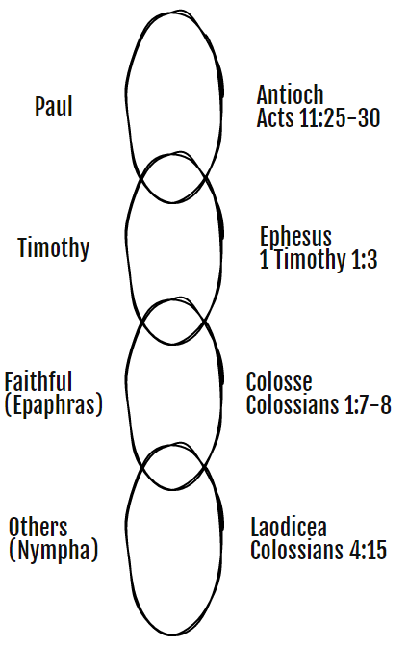
- Create an Instant Messaging group with your first level leaders only. These are your “Timothies”.
- Have your Timothies set up an Instant Messaging group with their first level leaders only.
- Every level sets up a group with those immediately one level below them
- Google how to set up groups in the specific messaging app.

Instant Messaging Apps
- Facebook Messenger
- WhatsApp
- Signal (secure)
- Telegram
- Telegard (secure)

