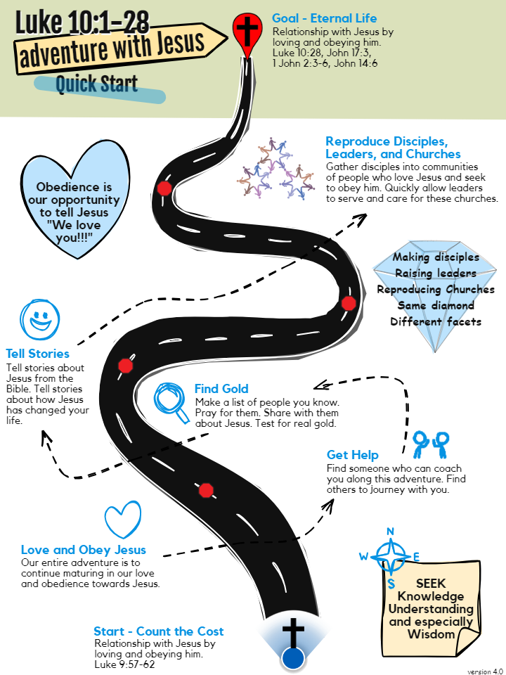
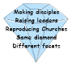  Adventure with Jesus | The start. The goal. And everything in between is about deepening our relationship (individually and corporately) with Jesus (Jn 17:3). We do this by loving and obeying him (1 Jn 2:3-6). Diligently pray for strength and guidance from the Holy Spirit. (John 16:13:15; Acts 1:8). At their core, the concepts of Glorifying God, and Abiding in Christ, Following Jesus, Worship and Eternal life are about loving and obeying Jesus.
Seek | KNOWLEDGE – What does God say in the Bible (Lk 10:26)?  UNDERSTANDING – What does it mean in the biblical times (Lk 10:26)? What does it mean to you, in your culture? What does it mean to the people you want to share about Jesus?  WISDOM – The practical application of KNOWLEDGE and UNDERSTANDING. This is the obedience part. We do it because we love Jesus (Lk 10:28).
Love and Obey Jesus | There are 7 General Commands of Jesus that we obey and help others to obey:  - Repent, believe the good news, receive the Holy Spirit (Mk 1:15; Jn 20:22)  - Baptize (Mt 28:19)  - Lord's Supper (Mt 26:26-28)  - Love God, Love Neighbors, Love Enemies, Love Believers (Mt 22:37-40)  - Pray in the Name of Jesus (Jn 16:24)  - Give (Lk 6:38; Mt 6:1-4)  - Make Disciples (Mt 28:18-20; 2 Ti 2:2)
Get Help | - Find someone who has at least a little more experience than you to coach you through this adventure. This can greatly add to your success (2 Ti 2:2).  - Find others to join this adventure (Mt 18:20, Lk 10:1) - at least 2 or more. Go as a church whom the gates of hell cannot overpower (Mt 16:18).
Find Gold | If you are going to a new place, find someone who has influence and can gather others to hear about Jesus. Have them create a list of people to pray for and to share about Jesus. When you share, make sure to invite them to follow Jesus. Work through them to help them share about Jesus and equip others. If you are working in your own place, work through your own networks of family and friends. Make a list of people you know and pray for them to know Jesus. Schedule time to visit them to share about Jesus and invite them to follow him. Always make sure to invest most of your time with people who are continually willing and ready to live out Jesus’ command to love and obey him.
Tell Stories | Everyone loves to hear stories. We tell stories to share the Good News which can be summarized in John 3:16. Stories like the Prodigal Son (Luke 15:11-32) are great to call people to repentance. Help people learn the stories by drawing them together. Practice with them to tell these stories and draw them with others. Send them out to do it.
Reproduce Disciples, Leaders, and Churches | A coach helps the players prepare for a match. However, the coach cannot play in the game. This is the concept of disciple-through. We help disciples, leaders, and churches to prepare for the work they will do. We practice with them. However, they must also go and do the work because they love Jesus. As they work, they will also disciple-through their disciples, leaders, and churches.  The continuing to disciple-through forms the chains that are described in Exodus 18:13-26 – Moses to leaders of 1000s to leaders of 100s to leaders of 50s and to leaders of 10s. It is also in 2 Timothy 2:2 – Paul to Timothy to Faithful to Others.  In this process, we release spiritual authority and responsibility (1 Peter 2:9). We entrust them to the grace of God (Acts 20:32).
Review | It is important to regularly review what we have learned. If you only look at a map once and never again, you won’t make it to your destination. At the foundation is our love and obedience to Jesus. Therefore, memorizing and reviewing the 7 General Commands of Jesus is essential. Regularly review the 7 General Commands, Jesus' mission strategy in Luke 10:1-28, Matt 28:18-20, and the elements explained in this map.

